

BACHELOR OF Engineering & Technology

SCHOOL OF COMPUTING SCIENCE AND ENGINEERING

PROJECT NAME : EASYOCR

Student Name & Admission No:

SHUBHAM SINGH 18SCSE1010436
Tushar Jasotani 18SCSE1010629

1 INTRODUCTION:
The goal of Optical Character Recognition (OCR) is to classify optical patterns (often contained in a digital image) corresponding to alphanumeric or other characters. The process of OCR involves several steps including segmentation, feature extraction, and classification. Each of these steps is a field unto itself, and is described briefly here in the context of a Matlab implementation of OCR.

One example of OCR is shown below
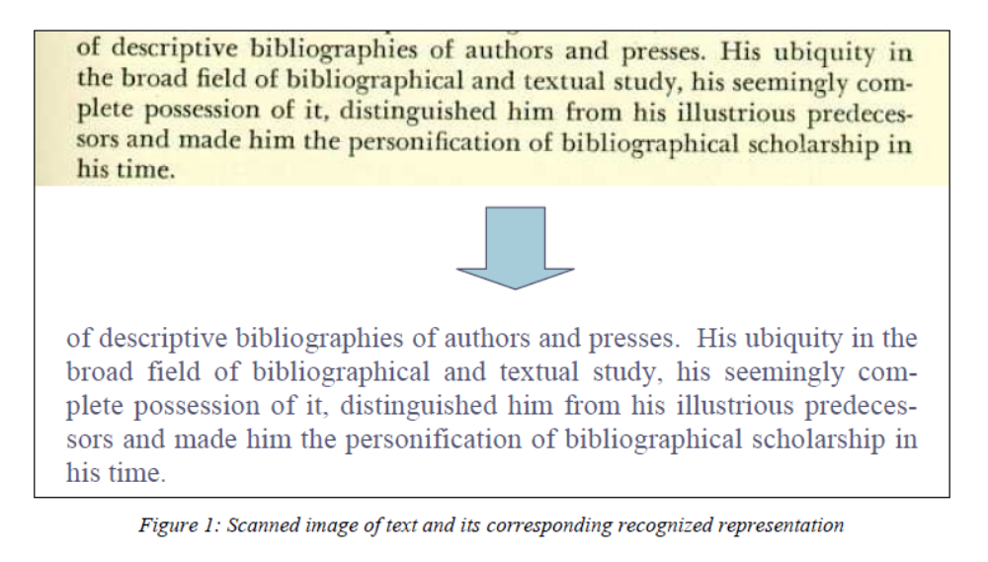
Therefore, Text capture is a process to convert analogue text based resources into digitally recognisable text resources. These digital text resources can be represented in many ways such as searchable text in indexes to identify documents or page images, or as full text resources. An essential first stage in any text capture process from analogue to digital will be to create a scanned image of the page side. This will provide the base for all other processes. The next stage may then be to use a technology known as Optical Character Recognition to convert the text content into a machine readable format.

Optical Character Recognition (OCR) is a type of document image analysis where a scanned digital image that contains either machine printed or handwritten script is input into an OCR software engine and translating it into an editable machine readable digital text format (like ASCII text).

OCR works by first pre-processing the digital page image into its smallest component parts with layout analysis to find text blocks, sentence/line blocks, word blocks and character blocks. Other features such as lines, graphics, photographs etc are recognised and discarded. The character blocks are then further broken down into components parts, pattern recognized and compared to the OCR engines large dictionary of characters from various fonts and languages. Once a likely match is made then this is recorded and a set of characters in the word block are recognized until all likely characters have been found for the word block. The word is then compared to the OCR engine’s large dictionary of complete words that exist for that language.

These factors of characters and words recognised are the key to OCR accuracy – by combining them the OCR engine can deliver much higher levels of accuracy. Modern OCR engines extend this accuracy through more sophisticated pre-processing of source digital images and better algorithms for fuzzy matching, sounds-like matching and grammatical measurements to more accurately establish word accuracy.

1.1 Different uses for OCR
There are many uses for the output from an OCR engine and these are not limited to a full text representation online that exactly reproduces the original. Because OCR can, in many circumstances, deliver character recognition accuracy that is below what a good copy typist would achieve it is often assumed it has little validity as a process for many historical documents. However, as long as the process is fitted to the information requirement then OCR can have a place even when the accuracy is relatively low (see Accuracy below for more details).
Potential uses include:
Indexing – the OCR text is output into a pure text file that is then imported to a search engine. The text is used as the basis for full text searching of the information resource. However, the user never sees the OCR’d text – they are delivered a page image from the scanned document instead. This allows for the OCR accuracy to be quite poor whilst still delivering the document to the user and providing searching capability. However, this mode of searching just identifies the document not necessarily the word or page on which it appears – in other terms it just indexes that those words appear in a specific item.

An example of this is
Full text retrieval – in this mode the OCR text is created as above but further work is done in the delivery system to allow for true full text retrieval. The search results are displayed with hit highlighting within the page image displayed. This is a valuable addition to the indexing option
from the perspective of the user. An example of this is the Forced Migration Online Digital Library2.
Full text representation – in this option the OCR’d text is shown to the end user as a representation of the original document. In this case the OCR must be very accurate indeed or the user will lose confidence in the information resource. All sorts of formatting issues in terms of the look and feel of the original are inherent within this option and it is rarely used with mark-up (see below) of some kind. The key factor is the accuracy and this leads to most projects having to check and correct OCR text to ensure the accuracy is suitable for publication with obvious time and cost implications.
Full text representation with xml mark-up - in this option the OCR output is presented to the end user with layout, structure or metadata added via the XML mark-up. In the majority of cases where OCR’d text is to be delivered there will be at least a minimal amount of mark-up done to represent structure or layout. Currently this process normally requires the highest amount of human intervention out of all the options listed here as OCR correction is very likely with additional mark-up of the content in someway. Many examples of digital text resources with XML mark-up may be found through the Text Encoding Initiative website3. The projects listed there also demonstrate the variety in levels of mark-up that are possible making it possible to vary activity to match the projects intellectual requirements and economic constraints.

1.2 Key issues for whether to use OCR
There are several key issues to consider in deciding whether to use OCR at all or choosing between different possible appropriate uses for the text output. The main factors to consider are a combination of accuracy, efficiency and the value gained from the process. If the accuracy is below 98% then considerations of the cost in terms of time and effort to proof read and correct the resource would have to be accounted for if a full text representation is to be made. For instance, see the EEBO production description for how the accuracy issue changed their potential approaches4. If the OCR engine is not capable to delivering the required accuracy then rekeying the text may become viable, but only if the intellectual value to be gained from having the rekeyed text matches the projects goals and budgets. Otherwise, OCR for indexing and retrieval may be the most viable option.

1.3 Accuracy
The majority of OCR software suppliers define accuracy in terms of a percentage figure based on the number of correct characters per volume of characters converted. This is very likely to be a misleading figure as it is normally based upon the OCR engine attempting to convert a perfect laser printed text of the modernity and quality of, for instance, the printed version of this document. So, if told that even the better OCR software could get 1 in 10,000 characters wrong and that it will then likely get more than one or two characters wrong in this document would this seem quite so impressive? It is more useful to know how accurate the OCR engine will be on pre-1950’s printed texts of very varying quality in terms of print and paper quality. In this context, it is highly unlikely that we will get 99.99% accuracy and we could assume that even the very best quality printed pre-1950’s resources will give no more than 98% (and most would be considerably less than that). In these scenarios the accuracy measure given by the software suppliers is not very useful in deciding whether OCR is appropriate to the original printed resource.

Regarding accuracy as a measurement of the amount of likely activity required to enable the text output to meet the defined requirements would be more useful.
In this context we might look at the number of words that are incorrect rather than number of characters. For example: a page of 500 words with 2,500 characters. If the OCR engine gives a result of 98% accuracy this equals 50 characters incorrect. However, looked at in word terms this could convert to 50 words incorrect (one character per word) and thus in word accuracy terms would equal 90% accuracy. If 25 words are inaccurate (2 characters on average per word) then this gives 95% in word accuracy terms. If 10 words were inaccurate (average of 5 characters per word) then the word accuracy is 98%. In terms of effort and usefulness the word accuracy matters more than the character accuracy – we can see the possibility of 5 times the effort to correct to 100% across the word accuracy range shown in this simple example. It is essential to remember that correcting OCR or text output is relatively expensive in terms of time and effort requiring both correction and proof reading activities – so it best to seek ways to avoid this additional activity if possible. The other consideration might be the usefulness of the text for indexing and retrieval purposes. If it is possible to achieve 90% character accuracy and still get 90% word accuracy, then most search engines utilising fuzzy logic would get in excess of 98% retrieval rate for straightforward prose text. In these cases the OCR accuracy may be of less interest than the potential retrieval rate for the resource (especially as the user will never see the OCR’d text to notice it isn’t perfect). In most prose

circumstances significant words and names are repeated which improves even more the chances of retrieval and can enable high retrieval rates for OCR accuracies measuring lower than 90%.

2 Classification Process
(Classification in general for any type of classifier) There are two steps in building a classifier: training and testing. These steps can be broken down further into sub-steps.
2.1 Training
a. Pre-processing – Processes the data so it is in a suitable form for…
b. Feature extraction – Reduce the amount of data by extracting relevant information—Usually results in a vector of scalar values. (We also need toNORMALIZE the features for distance measurements!)
c. Model Estimation – from the finite set of feature vectors, need to estimate a model (usually statistical) for each class of the training data
2.2 Testing
a. Pre-processing
b. Feature extraction – (both same as above)
c. Classification – Compare feature vectors to the various models and find the closest match. One can use a distance measure.

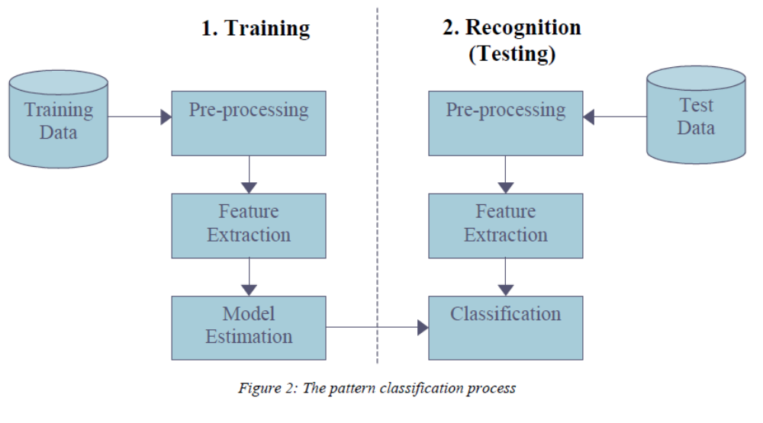

2.2.1 OCR – Pre-processing
These are the pre-processing steps often performed in OCR

2.2.1.1 Binarization – Usually presented with a grayscale image, binarization is then simply a matter of choosing a threshold value.
2.2.1.2 Morphological Operators – Remove isolated specks and holes in characters, can use the majority operator.
2.2.1.3 Segmentation – Check connectivity of shapes, label, and isolate. Can use Matlab 6.7’s
bwlabel and regionprops functions. Difficulties with characters that aren’t connected,
e.g. the letter i, a semicolon, or a colon (; or :). Segmentation is by far the most important aspect of the pre-processing stage. It allows the recognizer to extract features from each individual character. In the more complicated case of handwritten text, the segmentation problem becomes much more difficult as letters tend to be connected to each other.

2.2.2 OCR – Feature extraction
Given a segmented (isolated) character, what are useful features for recognition?
1. Moment based features
Think of each character as a pdf. The 2-D moments of the character are:
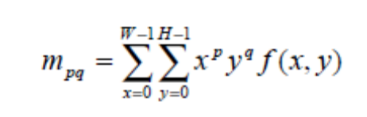

From the moments we can compute features like:
1. Total mass (number of pixels in a binarized character)
2. Centroid - Center of mass
3. Elliptical parameters
i. Eccentricity (ratio of major to minor axis)
ii. Orientation (angle of major axis)
4. Skewness
5. Kurtosis
6. Higher order moments
2. Hough and Chain code transform
3. Fourier transform and series

2.2.3 OCR - Model Estimation
Given labeled sets of features for many characters, where the labels correspond to the particular classes that the characters belong to, we wish to estimate a statistical model for each character class. For example, suppose we compute two features for each realization of the characters 0 through 9. Plotting each character class as a function of the two features we have:

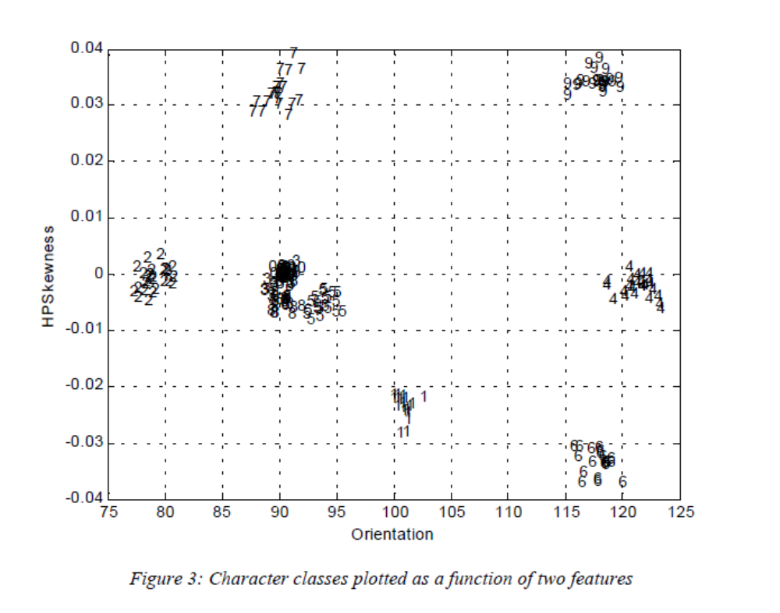

Each character class tends to cluster together. This makes sense; a given number should look about the same for each realization (provided we use the size font type and size). We might try to estimate a pdf (or pdf parameters such as mean and variance) for each character class. For example, in Figure 3, we can see that the 7’s have a mean Orientation of 90 and HPSkewness of 0.033.

2.2.4 OCR – Classification
According to Tou and Gonzalez, “The principal function of a pattern recognition system is to yield decisions concerning the class membership of the patterns with which it is confronted.” In the context of an OCR system, the recognizer is confronted with a sequence feature patterns from which it must determine the character classes.

A rigorous treatment of pattern classification is beyond the scope of this paper. We’ll simply note that if we model the character classes by their estimated means, we can use a distance measure for classification. The class to which a test character is assigned is that with the minimum distance.

3. MATLAB
3.1 What Is MATLAB?
MATLAB is a high-performance language for technical computing. It integrates computation, visualization, and programming in an easy-to-use environment where problems and solutions are expressed in familiar mathematical notation. Typical uses include:
•Math and computation
•Algorithm development
•Modeling, simulation, and prototyping
•Data analysis, exploration, and visualization
•Scientific and engineering graphics
•Application development, including graphical user interface building

MATLAB is an interactive system whose basic data element is an array that does not require dimensioning. This allows you to solve many technical computing problems, especially those with matrix and vector formulations, in a fraction of the time it would take to write a program in a scalar non-interactive language such as C or FORTRAN.

The name MATLAB stands for matrix laboratory. MATLAB was originally written to provide easy access to matrix software developed by the LINPACK and EISPACK projects. Today, MATLAB uses software developed by the LAPACK and ARPACK projects, which together represent the state-of-the-art

in software for matrix computation. MATLAB has evolved over a period of years with input from many users. In university environments, it is the standard instructional tool for introductory and advanced courses in mathematics, engineering, and science. In industry, MATLAB is the tool of choice for high-productivity research, development, and analysis.
3.2 Toolboxes
MATLAB features a family of application-specific solutions called toolboxes. Very important to most users of MATLAB, toolboxes allow you to learn and apply specialized technology. Toolboxes are comprehensive collections of MATLAB functions (M-files) that extend the MATLAB environment to solve particular classes of problems. Areas in which toolboxes are available include signal processing, control systems, neural networks, fuzzy logic, wavelets, simulation, and many others.
3.3 The MATLAB System
The MATLAB system consists of five main parts:
3.3.1 Development Environment:
This is the set of tools and facilities that help you use MATLAB functions and files. Many of these tools are graphical user interfaces. It includes the MATLAB desktop and Command Window, a command history, and browsers for viewing help, the workspace, files, and the search path.
3.3.2 The MATLAB Mathematical Function Library:
This is a vast collection of computational algorithms ranging from elementary functions like sum, sine, cosine, and complex arithmetic, to more sophisticated functions like matrix inverse, matrix eigen values, Bessel functions, and fast Fourier transforms.
3.3.3 The MATLAB language:
This is a high-level matrix/array language with control flow statements, functions, data structures, input/output, and object-oriented programming features. It allows both “programming in the small” to rapidly create quick and dirty throw-away programs, and “programming in the large” to create complete large and complex application programs.
3.3.4 Handle Graphics:
This is the MATLAB graphics system. It includes high-level commands for two-dimensional and three-dimensional data visualization, image processing, animation, and presentation graphics. It also includes low-level commands that allow you to fully customize the appearance of graphics as well as to build complete graphical user interfaces on your MATLAB applications.
3.3.5 The MATLAB Application Program Interface (API):
This is a library that allows you to write C and Fortran programs that interact with MATLAB. It include facilities for calling routines from MATLAB (dynamic linking), calling MATLAB as a computational engine, and for reading and writing MAT-files.
3.4 What Is Simulink?
Simulink, a companion program to MATLAB, is an interactive system for simulating nonlinear dynamic systems. It is a graphical mouse-driven program that allows you to model a system by drawing a block diagram on the screen and manipulating it dynamically. It can work with linear, nonlinear, continuous-time, discrete-time, multirate, and hybrid systems. Blocksets are add-ons to Simulink that provide additional libraries of blocks for specialized applications like communications, signal processing, and power systems. Real-Time Workshop is a program that allows you to generate C code from your block diagrams and to run it on a variety of real-time systems.

3.5 What Is Stateflow?
Stateflow is an interactive design tool for modeling and simulating complex reactive systems. Tightly integrated with Simulink and MATLAB, Stateflow provides Simulink users with an elegant solution for designing embedded systems by giving them an efficient way to incorporate complex control and supervisory logic within their Simulink models. With Stateflow, you can quickly develop graphical models of event-driven systems using finite state machine theory, statechart formalisms, and flow diagram notation. Together, Stateflow and Simulink serve as an executable specification and virtual prototype of your system design.
3.6 Matlab Commands Required:
Clc:
Clear Command Window
Clear:
Remove items from workspace, freeing up system memory
Clear:
Remove specified figure
Title:
Add title to current axes
Load:
Load workspace variables from disk
Inputdlg:
Create and open input dialog box
Isa:
Determine whether input is object of given class

Length:
Length of vector
Linspace:
Generate linearly spaced vectors
The Linspace function generates linearly spaced Vectors. It is similar to the colon operator ":", but gives direct control over the number of points
Wthresh:
Soft or hard thresholding
Subplot:
Create axes in tiled positions
Rand:
Uniformly distributed pseudorandom numbers
Thselect:
Threshold selection for de-noising
Wnoise:
Noisy wavelet test data
Imread:
IMREAD Read image from graphics file.
A = IMREAD(FILENAME,FMT) reads a grayscale or color image from the file specified by the string FILENAME. If the file is not in the current directory, or in a directory on the MATLAB path, specify the full pathname.

Imwrite:
IMWRITE Write image to graphics file.
IMWRITE(A,FILENAME,FMT) writes the image A to the file specified by FILENAME in the format specified by FMT.

A can be an M-by-N (grayscale image) or M-by-N-by-3 (color image) array. A cannot be an empty array. If the format specified is TIFF, IMWRITE can also accept an M-by-N-by-4 array containing color data that uses the CMYK color space.
IMSHOW Display image in Handle Graphics figure.
IMSHOW(I) displays the grayscale image I.

Imshow:

IMSHOW(I,[LOW HIGH]) displays the grayscale image I, specifying the display
range for I in [LOW HIGH]. The value LOW (and any value less than LOW)
displays as black, the value HIGH (and any value greater than HIGH) displays
as white. Values in between are displayed as intermediate shades of gray,
using the default number of gray levels. If you use an empty matrix ([]) for
[LOW HIGH], IMSHOW uses [min(I(:)) max(I(:))]; that is, the minimum value in
I is displayed as black, and the maximum value is displayed as white.

4.SOURCE CODE
Ocr.m
%%%%%%%%%%%%%%%%%%%%%%%%%%%%%%%%%%%%%%%
% OCR (Optical Character Recognition).
%%%%%%%%%%%%%%%%%%%%%%%%%%%%%%%%%%%%%%%%

warning off
clc,
close all,
clear all
imagen=imread('2.jpg');
imshow(imagen);
title('INPUT IMAGE WITH NOISE')
if size(imagen,3)==3 %RGB image
imagen=rgb2gray(imagen);
end
% Convert to BW
threshold = graythresh(imagen);
imagen =~im2bw(imagen,threshold);
% Remove all object containing fewer than 30 pixels
imagen = bwareaopen(imagen,30);
%Storage matrix word from image
word=[ ];
re=imagen;
%Opens text.txt as file for write
fid = fopen('ocr.txt', 'wt');
% Load templates
load templates
global templates
% Compute the number of letters in template file
num_letras=size(templates,2);

while 1
%Fcn 'lines' separate lines in text
[fl re]=lines(re);
imgn=fl;
%Uncomment line below to see lines one by one
%imshow(fl);pause(0.5)
%-----------------------------------------------------------------
% Label and count connected components
[L Ne] = bwlabel(imgn);
for n=1:Ne
[r,c] = find(L==n);
% Extract letter
n1=imgn(min(r):max(r),min(c):max(c));
% Resize letter (same size of template)
img_r=imresize(n1,[42 24]);
%Uncomment line below to see letters one by one
%imshow(img_r);pause(0.5)
%-------------------------------------------------------------------
% Call fcn to convert image to text
letter=read_letter(img_r,num_letras);
% Letter concatenation
word=[word letter];
end
%fprintf(fid,'%s\n',lower(word));%Write 'word' in text file (lower)
fprintf(fid,'%s\n',word);%Write 'word' in text file (upper)
% Clear 'word' variable
word=[ ];
%*When the sentences finish, breaks the loop
if isempty(re) %See variable 're' in Fcn 'lines'
break
end
end
fclose(fid);

%Open 'text.txt' file
winopen('ocr.txt')
clear all

Create_templates.m:
%%%%%%%%%%%%%%%%%%%%%%%%%%%%%%%%%%%%%%%%%%%%
%%CREATE TEMPLATES
%%%%%%%%%%%%%%%%%%%%%%%%%%%%%%%%%%%%%%%%%%%%

%Letters
A=imread('letters_numbers\A.bmp');B=imread('letters_numbers\B.bmp');
C=imread('letters_numbers\C.bmp');D=imread('letters_numbers\D.bmp');
E=imread('letters_numbers\E.bmp');F=imread('letters_numbers\F.bmp');
G=imread('letters_numbers\G.bmp');H=imread('letters_numbers\H.bmp');
I=imread('letters_numbers\I.bmp');J=imread('letters_numbers\J.bmp');
K=imread('letters_numbers\K.bmp');L=imread('letters_numbers\L.bmp');
M=imread('letters_numbers\M.bmp');N=imread('letters_numbers\N.bmp');
O=imread('letters_numbers\O.bmp');P=imread('letters_numbers\P.bmp');
Q=imread('letters_numbers\Q.bmp');R=imread('letters_numbers\R.bmp');
S=imread('letters_numbers\S.bmp');T=imread('letters_numbers\T.bmp');
U=imread('letters_numbers\U.bmp');V=imread('letters_numbers\V.bmp');
W=imread('letters_numbers\W.bmp');X=imread('letters_numbers\X.bmp');
Y=imread('letters_numbers\Y.bmp');Z=imread('letters_numbers\Z.bmp');
%Number
one=imread('letters_numbers\1.bmp'); two=imread('letters_numbers\2.bmp');
three=imread('letters_numbers\3.bmp');four=imread('letters_numbers\4.bmp');
five=imread('letters_numbers\5.bmp'); six=imread('letters_numbers\6.bmp');
seven=imread('letters_numbers\7.bmp');eight=imread('letters_numbers\8.bmp');
nine=imread('letters_numbers\9.bmp'); zero=imread('letters_numbers\0.bmp');

letter=[A B C D E F G H I J K L M N O P Q R S T U V W X Y Z];
number=[one two three four five...
six seven eight nine zero];
character=[letter number];
templates=mat2cell(character,42,[24 24 24 24 24 24 24 ...
24 24 24 24 24 24 24 ...
24 24 24 24 24 24 24 ...
24 24 24 24 24 24 24 ...
24 24 24 24 24 24 24 24]);
save ('templates','templates')
clear all

lines.m
function [fl re]=lines(im_texto)
% Divide text in lines
% im_texto->input image; fl->first line; re->remain line
% Example:
% im_texto=imread('TEST_3.jpg');
% [fl re]=lines(im_texto);
% subplot(3,1,1);imshow(im_texto);title('INPUT IMAGE')
% subplot(3,1,2);imshow(fl);title('FIRST LINE')
% subplot(3,1,3);imshow(re);title('REMAIN LINES')
im_texto=clip(im_texto);
num_filas=size(im_texto,1);
for s=1:num_filas
if sum(im_texto(s,:))==0
nm=im_texto(1:s-1, :); % First line matrix
rm=im_texto(s:end, :);% Remain line matrix
fl = clip(nm);
re=clip(rm);
%*-*-*Uncomment lines below to see the result*-*-*-*-
% subplot(2,1,1);imshow(fl);
% subplot(2,1,2);imshow(re);
break
else
fl=im_texto;%Only one line.
re=[ ];
end
end

function img_out=clip(img_in)
[f c]=find(img_in);
img_out=img_in(min(f):max(f),min(c):max(c));%Crops image

raed_letter.m
function [fl re]=lines(im_texto)
% Divide text in lines
% im_texto->input image; fl->first line; re->remain line
% Example:
% im_texto=imread('TEST_3.jpg');
% [fl re]=lines(im_texto);
% subplot(3,1,1);imshow(im_texto);title('INPUT IMAGE')
% subplot(3,1,2);imshow(fl);title('FIRST LINE')
% subplot(3,1,3);imshow(re);title('REMAIN LINES')
im_texto=clip(im_texto);
num_filas=size(im_texto,1);
for s=1:num_filas
if sum(im_texto(s,:))==0
nm=im_texto(1:s-1, :); % First line matrix
rm=im_texto(s:end, :);% Remain line matrix
fl = clip(nm);
re=clip(rm);
%*-*-*Uncomment lines below to see the result*-*-*-*-
% subplot(2,1,1);imshow(fl);
% subplot(2,1,2);imshow(re);
break
else
fl=im_texto;%Only one line.
re=[ ];
end
end

function img_out=clip(img_in)
[f c]=find(img_in);
img_out=img_in(min(f):max(f),min(c):max(c));%Crops image

6.CONCLUSION
Recognition of Latin-script, typewritten text is still not 100% accurate even where clear imaging is available. One study based on recognition of 19th and early 20th century newspaper pages concluded that character-by-character OCR accuracy for commercial OCR software varied from 71% to 98%^{[2]}; total accuracy can only be achieved by human review. Other areas—including recognition of hand printing, cursive handwriting, and printed text in other scripts (especially those East Asian language characters which have many strokes for a single character)—are still the subject of active research.
Accuracy rates can be measured in several ways, and how they are measured can greatly affect the reported accuracy rate. For example, if word context (basically a lexicon of words) is not used to correct software finding non-existent words, a character error rate of 1% (99% accuracy) may result in an error rate of 5% (95% accuracy) or worse if the measurement is based on whether each whole word was recognized with no incorrect letters.

5.References
- ^ "Reading Machine Speaks Out Loud" , February 1949, Popular Science.
- ^ Holley, Rose (Apr 2009). "How Good Can It Get? Analysing and Improving OCR Accuracy in Large Scale Historic Newspaper Digitisation Programs". D-Lib Magazine. http://www.dlib.org/dlib/march09/holley/03holley.html. Retrieved 5 Jan 2011.
- ^ Suen, C.Y., et al (1987-05-29), Future Challenges in Handwriting and Computer Applications, 3rd International Symposium on Handwriting and Computer Applications, Montreal, May 29, 1987, http://users.erols.com/rwservices/pens/biblio88.html#Suen88
- ^ Tappert, Charles C., et al (1990-08), The State of the Art in On-line Handwriting Recognition, IEEE Transactions on Pattern Analysis and Machine Intelligence, Vol 12 No 8, August 1990, pp 787-ff, http://users.erols.com/rwservices/pens/biblio90.html#Tappert90c, retrieved 2008-10-03
- ^ LeNet-5, Convolutional Neural Networks
- ^ Milian, Mark (December 20, 2010). "New iPhone app translates foreign-language signs". CNN: Tech. http://www.cnn.com/2010/TECH/mobile/12/20/word.lens.iphone.app/index.html. Retrieved December 20, 2010.

